Information
about proposing humanitarian projects
for co-financing

1. Project name: «A school stadium improvement with modern equipment for organizing work to promote physical education and sports and a healthy
lifestyle ».
2. Implementation period: 24 months.
3. Applicant organization proposing the project: a state educational establishment «Secondary school № 2, Gantsevichy».
4. The aim of the project: creating the conditions for physical education, keeping the health of Gantsevichy secondary schools students and adults through a school stadium improvement.
5. Tasks planned for implementation within the project:
1. To change the infrastructure of school sports and health equipment.
2. To create friendly conditions for physical education, sports and leisure for Gantsevichy secondary schools students and adults.
3. To form a sustainable interest to regular physical education and sports studying.
4. To promote active types of physical education and sport activities and a healthy lifestyle.
6.Target group: Gantsevichy secondary schools students and adults.
7. Brief summary within the project:
1. working out design and estimate documentation for a school stadium improvement.
2. working on changing the infrastructure of school sports and health equipment:
Replacement of the sand coating of an athletics treadmill
with a synthetic one
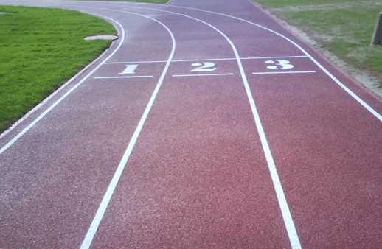

Modernization of the gymnastic town in accordance with modern requirements for equipment
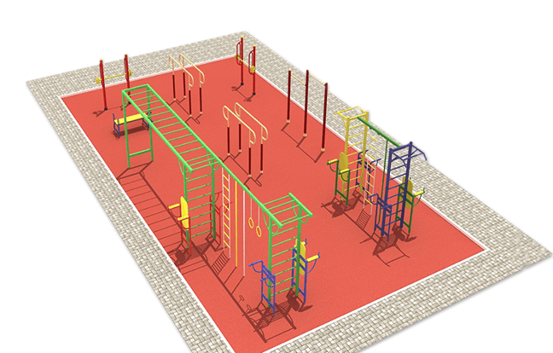

Arrangement of a platform for street sports simulators
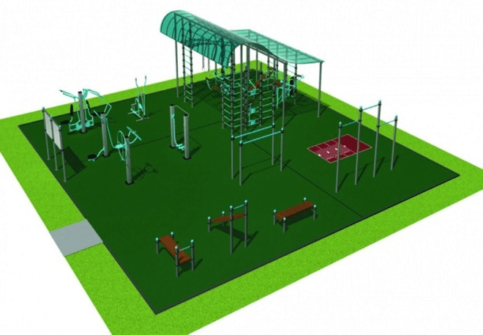

Reconstruction of basketball and volleyball court, mini football fields
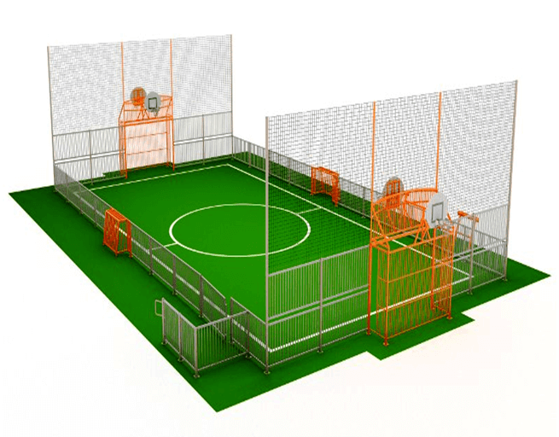
3. The grand opening of the school stadium, the holding of a sports festival « School- territory for sports».
4. Organization of socially significant social activities of students, contributing to the acquisition of sports skills and abilities from them, introduction to a healthy lifestyle, improving the functional capabilities of the body of students, increasing the level of physical development.
5. Organization of join leisure, sports events, holiday and competitions of students together with their parents.
8. Total funding (in US dollars): 300 000
Source of funding | Amount of funding (in US dollars)
Donor funds | 295 000
Co-financing | 5 000
9. Location of project (region / district): Republic of Belarus, Brest region, Gantsevichy, Kalinovsky str. 36.
10. Contact: E. A. Rabtsevich, headmaster, 80164668516, e-mail: sch2gancevichi@yandex.by

