**Humanitarian project the state educational institution**

**«Kindergarten No. 6 in Oshmyany»**

**«Safe childhood»** 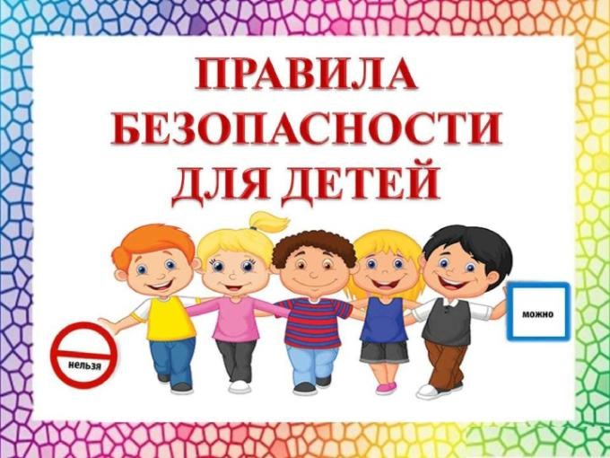

|  |  |
| --- | --- |
| 1 | Project name: "Safe childhood» |
| 2 | Project implementation period: 2023-2024 |
| 3 | Applicant organization offering the project: State-owned educational institutions «Kindergarten No. 6 in Oshmyany» |
| 4 | The objectives of the project: Promotion of health and safety. Creating a safe environment for preschool children. |
| 5 | Tasks planned for implementation within the framework of the project: Forming the security basics. This is the formation of primary ideas about safe behavior in everyday life, society, and nature.  Education of a conscious attitude to the implementation of safety rules. Formation of a cautious and circumspect attitude to the potential dangerous situations for humans and the natural world.  Formation of ideas about some typical dangerous situations and methods of behavior in them.  The formation of elementary representations about the safety rules of the road.  Education of a conscious attitude to the need to comply with the rules life safety.  In the second youngest group: Form ideas about the simplest relationships in living and inanimate nature.  In the middle group: Continue to introduce the diversity of the animal and plant world, phenomena of inanimate nature. Form a concept "edible", "inedible", "medicinal plants".  In the senior group: Form the basics |
| 6 | Target group: preschool children, parents, preschool teachers |
| 7 | Brief description of the project activities: organized and events are held for children to develop skills of safe |

|  |  |  |
| --- | --- | --- |
|  | behavior, security is broadcast as the basis of life,  reconstruction of shady canopies with the organization and design of thematic zones. | |
| 8 | The total amount of funding (in US dollars): 4 000 | |
| Source of financing | Объем финансирования (в долларах США) |
| Donor funds | 3 000 |
| Co-financing | 1 000 |
| 9 | Place of project realization: Grodno region, Oshmyany lane Ya. Kolosa, 14 GUO «Kindergarten No. 6 in Oshmyany» | |
| 10 | Contact person: Svetlana Chirkova, head, 80159371246,  +375 44 7535320 | |