[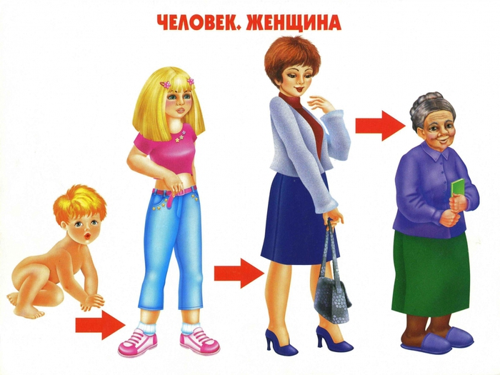](https://www.liveinternet.ru/journal_proc.php?action=redirect&url=//img1.liveinternet.ru/images/attach/c/6/89/542/89542707_large_4979214_001.jpg)

[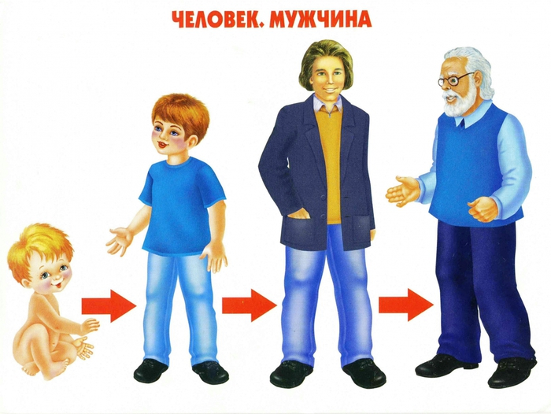](https://www.liveinternet.ru/journal_proc.php?action=redirect&url=//img0.liveinternet.ru/images/attach/c/6/89/542/89542708_large_4979214_002.jpg)

[[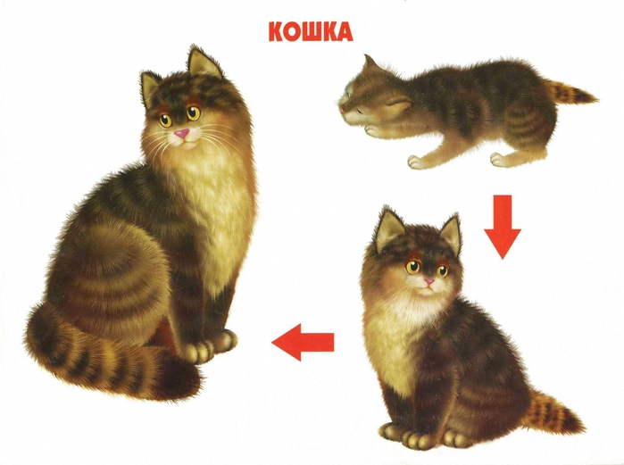](https://www.liveinternet.ru/journal_proc.php?action=redirect&url=//img1.liveinternet.ru/images/attach/c/6/89/542/89542719_large_4979214_012.jpg)](https://www.liveinternet.ru/journal_proc.php?action=redirect&url=//img1.liveinternet.ru/images/attach/c/6/89/542/89542719_large_4979214_012.jpg) 