Humanitarian project

Humanitarian project "Creating a modern image of a playground". We invite you to cooperate



Humanitarian project of the GUO "Mykolaiv nursery-garden of the Shumilinsky district" to create a modern image of a playground

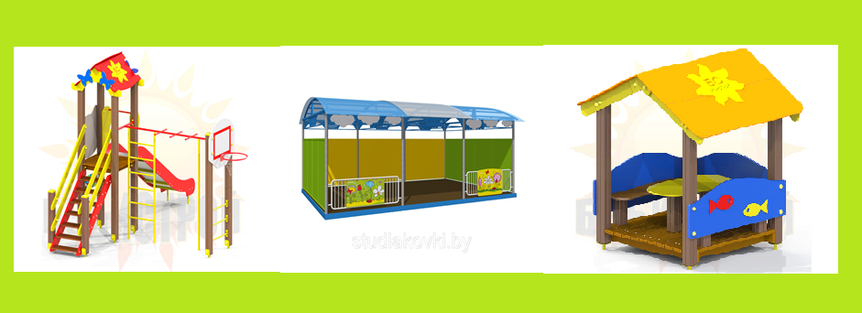

1. Name of the project

Creation of a modern image of a playground (Reconstruction of a complex playground on the territory of the GUO "Nikolaevsky nursery-garden of the Shumilinsky district" in accordance with modern safety requirements)

2. Project implementation period

12 months from the start of the project.

3. The applicant organization offering the project

GUO "Nikolaevsky nursery-garden of the Shumilinsky district". 211269 Vitebsk region, Shumilinsky district, Nikolaevo village, Tsentralnaya str., 31

4. The purpose of the project

To create emotionally favorable conditions for children's stay in

a preschool institution through landscaping and organization of cognitive, creative, recreational, sports activities of pupils during their stay at the nursery-garden site at any time of the year.

5. Tasks planned for implementation within the framework of the project

1. To improve and modernize the territory

of the preschool education institution in accordance with modern

requirements and methodological recommendations to ensure

high-quality organization of the educational process with children from 2 to 7 years old

during physical culture leisure activities, walks, organization

of new forms of preschool education.

2. To create a comfortable environment for the life of children on the territory

of the institution.

3.To use modern technologies in working with preschool

children to form and strengthen health, increase

motor activity of preschoolers.

6. Target Group

Children aged 2 to 7 years, the maximum number of pupils is 19.

7. A brief description of the activities within the project

This project is planned for the purpose of landscaping the territory

of the preschool education institution. The project was developed taking into account

the requirements for the maintenance of the sites of the preschool education institution.

This approach helps teachers to show their full creative potential.

As part of the project, it is planned to purchase and install:

a shade canopy with benches (1 piece);

Gazebo house (1 piece);

Children's play complex (1 pc);

8. Total funding (in US dollars): 4,650

|  |  |
| --- | --- |
| Source of financing | Amount of financing  in US dollars |
| Donor funds | 4 500 |
| Co-financing | 150 |

9. Place of project implementation (region/district, city):

Republic of Belarus, Vitebsk region, Shumilinsky district, Nikolaevo village, Tsentralnaya str., 31 GUO "Nikolaevsky nursery garden of Shumilinsky district"

10. Contact person: V.L.Kukharev, Head of the State Educational Institution "Nikolaevsky nursery-garden of the Shumilinsky district", tel. 8 02130 5 75 28; + 37529 500 43 49, [nikolaevods@yandex.by](mailto:nikolaevods@yandex.by),

We will be very glad to cooperate!