**Route №7.**

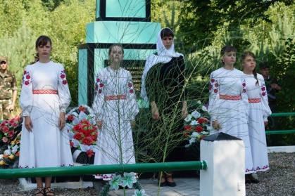**«War-burned village» (The events of war history, that is associated with the battles on the Ozery territory during the First World War and the Second World War**

**Route №8, №9**

**«Walk around modern Ozery»**

**(A cycling route around village, neighboring villages and their sights)**

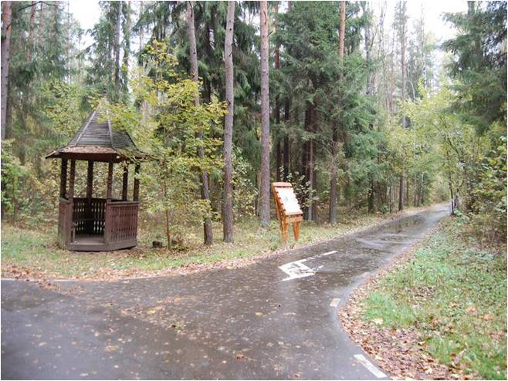

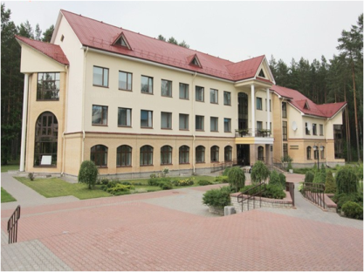

**«Nature created people as they are, and has given them great consolation from many evils - family and Homeland».**

**Our addres: Гродненская область и район,**

**аг. Озёры, ул. Строителей,2**

**Phone/fax: 931-4-25**

**e-mail:** [**ozery@tut.by**](mailto:ozery@tut.by)

**School email address:**

**ozery.schools.by**

**State educational institution «Secondary school in Ozery»**

**«I'm exploring my agrogorodok»**

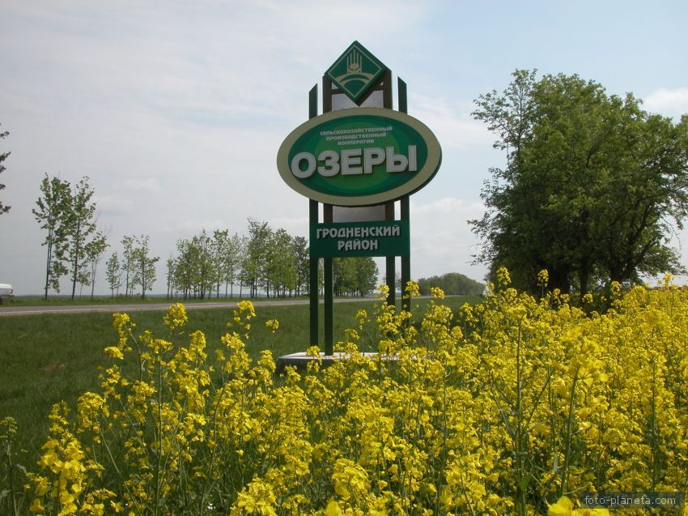

**Ozery, 2018**

**Route №1.**

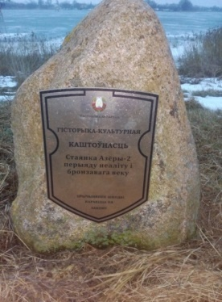**«Primordial Ozery»**

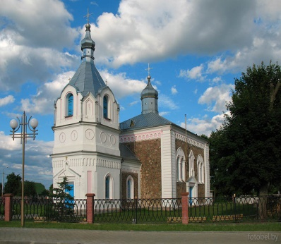**(** **An excursion takes you to the times where so-called primitive people appear . The school museum offers excavation materials)**

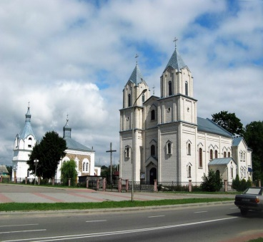**Route №2.**

**«** **The history of the Catholic parish» (The visit to the church of Christ the Lord, it is the old Catholic necropolis, where the grave of the Rebels (1863-1864s) is located)**

**Route №3**

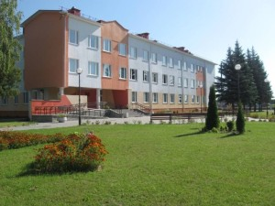**«** **Church of the Holy Spirit – a stronghold of Orthodoxy in Grodno» (The visit at the stone "muravjevka" Church, mid-XIX century; a familiarity with the history of the Temple, its architecture, its interior features and Мiraculous icons)**

**Route №4.**

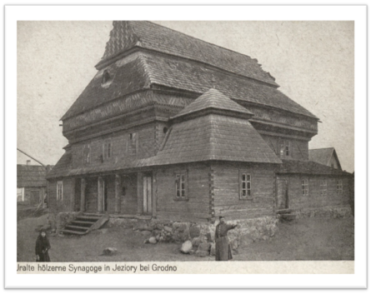**«** **The history of the Jewish community in Yeziory »**

**(The history of the rise and existence of the Jewish community in Yeziori; familiarity with the peculiarities of the Holocaust)**

**Route №5.**

**«Development of education in Ozery» (Familiarity with the rise of the region education) - the history of the public school, education in 1918-1939s, the Soviet school, the history of the creation and development of modern school)**

**Route №6.**

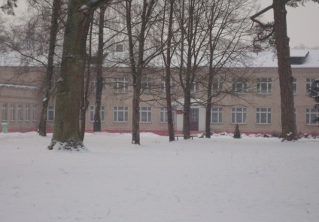 **«The town under the leadership of the Count Levashov» (The history of the town under the rule of the Count Levashov; excursion to the count's estate)**