The name of the project : “Teenage activity in a peaceful direction ”
Project timeline: 2023-2024
The applicant organization offering the project: State Educational
Institution "Novoselkovsky school"
The goal of the project: prevention of deviant behavior among adolescents through physical education and sport
Tasks planned for implementation in the framework of the project:
-improvement of the sports material and technical base of the educational institution;
-education of ethical , moral and volitional qualities and re-education of negative manifestations in the behavior of adolescents through physical education and sport;
Being busy in their free time, in sports sections meeting the modern requirements of children and their legal representatives.
Target group: teenage students
Brief description of project activities:
State Educational Institution "Novoselkovsky school» takes the initiative to improve the sports material and technical base, to organize activities alternative to deviant behavior.
The equipment installed here (climbing wall, wrestling carpet), purchased equipment (air rifle for biathlon, kimono for hand-to-hand fight, hockey skates, tourist tents, sleeping bags, etc.) will contribute to the stimulation of motor activity, popularization of physical culture and sport, and healthy lifestyle in general.
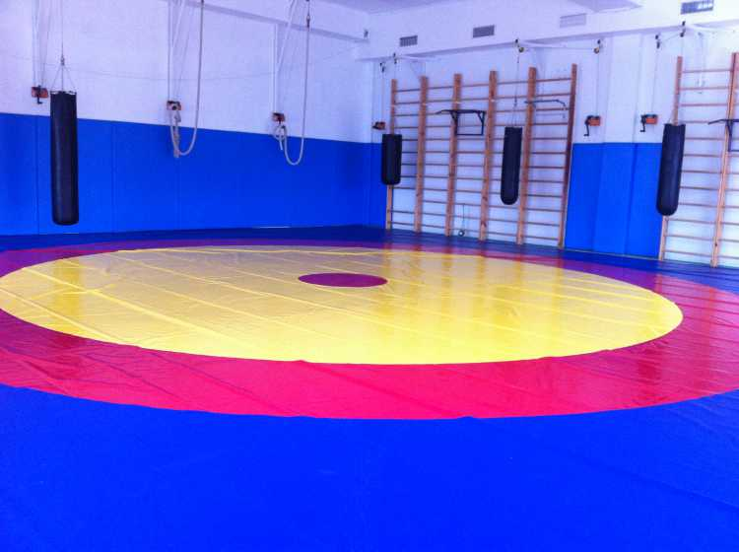
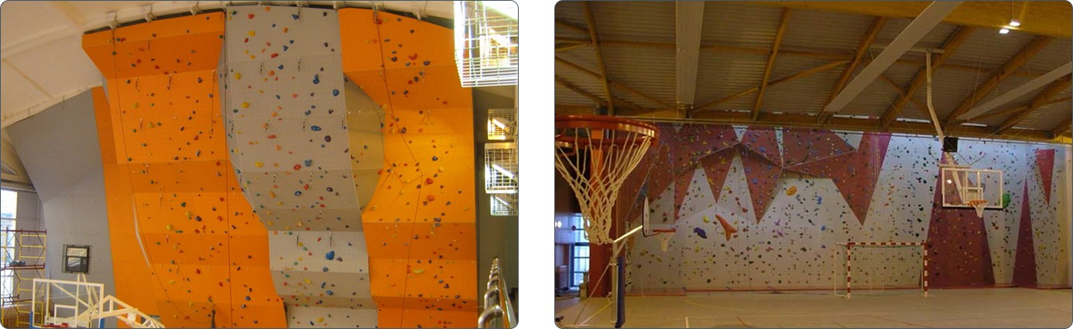

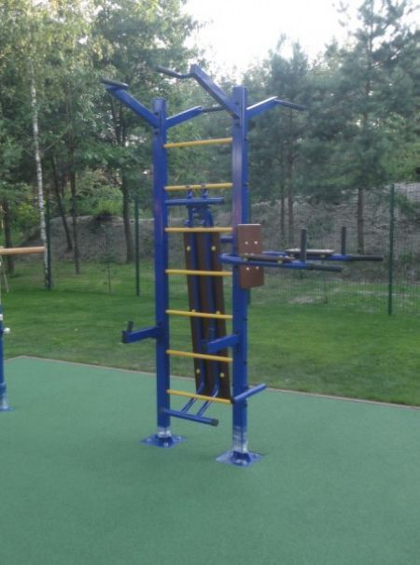

Total funding (in US dollars ) 5000
Location of the project (region / district, city): Grodno region, Oshmiany district, agro-town Novoselki, 57 Tsentralnaya St..
Contact person:N.A.Trot, director of the educational institution
+375296438064. Srnov@mail.grodno.by

