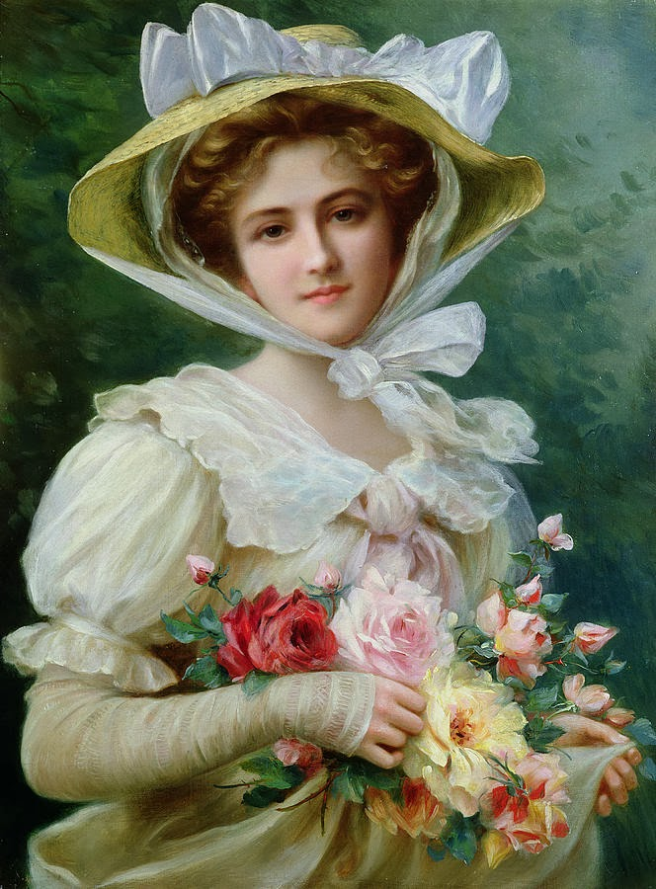

**[Эмиль Вернон](https://yandex.by/images/search?text=%D0%AD%D0%BC%D0%B8%D0%BB%D1%8C%20%D0%92%D0%B5%D1%80%D0%BD%D0%BE%D0%BD%20%D0%B6%D0%B5%D0%BD%D1%81%D0%BA%D0%B8%D0%B5%20%D0%BF%D0%BE%D1%80%D1%82%D1%80%D0%B5%D1%82%D1%8B&source=related-duck" \t "_self)**