22.07.2019

Об участии в конкурсе

Управление по образованию Минского райисполкома в соответствии с письмом главного управления по образованию Миноблисполкома №3-2/996 от 22.07.2019 направляет информацию о XXVII ежегодном международном конкурсе детского рисунка. Срок подачи работ – по 30 сентября 2019 года, возраст участников – 6-15 лет.

Реквизиты для прямых контактов с организаторами: Ie-No-Hikari

Association, “The World’s Children Contest”, 11, Funagawara-cho, Ichigaya, Shinjuku, Tokyo, 162-8448, Japan; сайт <https://www.ienohikari->

koubo.com/zugacon/english/; эл. почта zugakon@ienohikari.or.jp.

Дополнительную информацию можно получить в загранучреждении, контактное лицо – третий секретарь Филич А.А., тел. +81-3-3448-1623, эл. почта japan.cjnsul@mfa.gov.by.

Необходимо проинформировать заинтересованных и до 30.08.2019 года сообщить об участии в мероприятии Наумович О.В. (2040630, 80291552634)

Приложение: на 6 л.

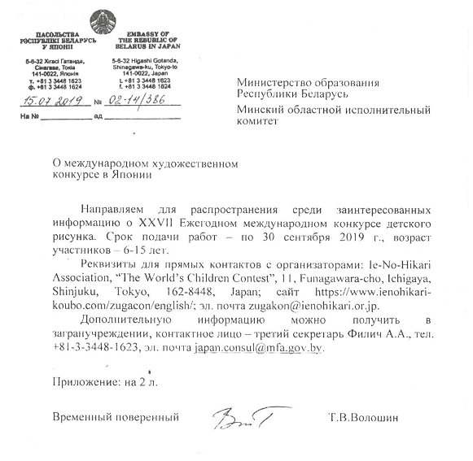

|  |  |  |  |  |  |  |  |
| --- | --- | --- | --- | --- | --- | --- | --- |
| Individual | | Entry Attaching Label | |  | World Children's Picture Contest | | |
|  | *You must fill in the form with black pen in English **(block letters).** | | | |  |  |  |
|  | *Detach this Label, and paste on your picture backside. | |  |  |  |  |  |
|  | *If you need additional this Label, please attach the copies this form. | | | |  |  |  |
|  | **Original Title of Picture (Please be sure to put a title)** | | | |  |  |  |
|  |  |  |  |  |  |  |  |
|  |  |  |  |  |  |  |  |
|  | **Given Name (First Name)** | |  | **Middle Name (Christian Name)** | |  |  |
|  |  |  |  |  |  |  |  |
|  | **Surname (Family Name / Last Name)** | |  |  |  |  |  |
|  |  |  |  |  |  |  |  |
|  | **Country of Residence (e.g.JAPAN)** | |  | **Sex *Please check ✓ the Box** | | **Age** |  |
|  |  |  |  | □**Male** | □**Female** |  |  |
|  | **Your Address** |  |  |  |  |  |  |
|  |  |  |  |  |  |  |  |
|  |  |  |  | **Postal Code** |  |  |  |
|  | **TEL (Please print : 0123456789)** | |  | **FAX (Please print : 0123456789)** | |  |  |
|  |  |  |  |  |  |  |  |
|  | **e-mail (Please print :** ○○○○＠○○○○**.**○○**.**○○**）** | |  |  |  |  |  |
|  |  |  |  |  |  |  |  |
|  | **How did you know this contest ?** | |  |  |  |  |  |
|  | □**DM**□**Our Website**□**Your school**□**JICA(Japan International Cooperation Agency)**□**Embassy,Consulate**□**other( )** | | | | | |  |
|  |  |  |  |  |  |  |  |

|  |  |  |  |  |  |  |  |  |  |  |  |  |
| --- | --- | --- | --- | --- | --- | --- | --- | --- | --- | --- | --- | --- |
| Organization | | | | Entry List | |  | |  | World Children's Picture Contest | | | |
|  | | *You must fill in the form with black pen in English **(block letters)**. | | | | | | |  | |  | |
|  | | *If you need additional this List, please attach the copies this form. | | | | | | |  | |  | |
|  | | *Be enclosed this List when you send the pictures. | | | | | |  |  | |  | |
|  | | **Name of Organization** | |  | |  | |  |  | |  | |
|  | |  | |  | |  | |  |  | |  | |
|  | | **Staff/Teacher/Instructor/Sender** | | | |  | |  |  | |  | |
|  | | □**Mr.** □**Mrs.** □**Ms.** | |  | |  | |  |  | |  | |
|  | | **Address of Organization** | |  | |  | |  |  | |  | |
|  | |  | |  | |  | |  |  | |  | |
|  | |  | |  | |  | | **Postal Code** |  | |  | |
|  | | **TEL (Please print : 0123456789)** | | | |  | | **FAX (Please print : 0123456789)** | | |  | |
|  | |  | |  | |  | |  |  | |  | |
|  | | **e-mail (Please print :** ○○○○＠○○○○**.**○○**.**○○**）** | | | |  | |  |  | |  | |
|  | |  | |  | |  | |  |  | |  | |
|  | | **Number of the entry pictures** | | | |  | | **Number of total entries** |  | |  | |
|  | | *please fill in the number of the pictures you will sent. | | | |  | | *if you select the pictures, please note the total number of entries. | | | | |
|  | |  | |  | |  | |  |  | |  | |
|  | | **How did you know this contest ?** | | | |  | |  |  | |  | |
|  | | □**DM**□**Our Website**□**Your school**□**JICA(Japan International Cooperation Agency)**□**Embassy,Consulate**□**other( )** | | | | | | | | | | |
|  | |  | |  | |  | |  |  | |  | |
| Organization | | | Entry Attaching Label | | | |  | | | World Children's Picture Contest | | | | |
|  | *Please detach this Label, and paste on your picture backside. | | | | | |  | | |  | |  | |  |
|  | **Original Title of Picture** | |  | |  | |  | | |  | |  | |  |
|  |  | |  | |  | |  | | |  | |  | |  |
|  |  | |  | |  | |  | | |  | |  | |  |
|  | **Given Name (First Name)** | | | |  | | **Middle Name (Christian Name)** | | | | |  | |  |
|  |  | |  | |  | |  | | |  | |  | |  |
|  | **Surname (Family Name / Last Name)** | | | |  | |  | | |  | |  | |  |
|  |  | |  | |  | |  | | |  | |  | |  |
|  | **Country of Residence (e.g.JAPAN)** | | | |  | | **Sex *Please check ✓ the Box** | | | | | **Age** | |  |
|  |  | |  | |  | | □**Male** | | | □**Female** | |  | |  |
|  | **Name of Organization** | |  | |  | |  | | |  | |  | |  |
|  |  | |  | |  | |  | | |  | |  | |  |
|  |  | |  | |  | |  | | |  | |  | |  |

