Humanitarian project of the state educational institution “Bocheikovskaya secondary school of the Beshenkovichi district”

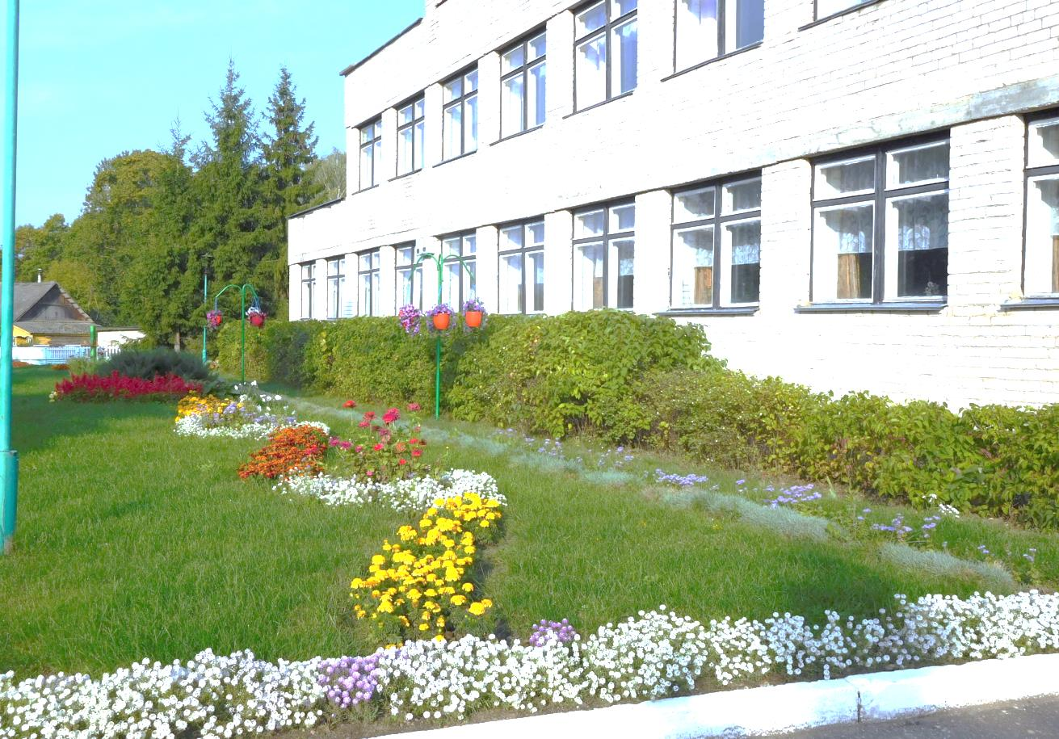

**Project Name: "Being healthy is great"**

**Applicant organization:** State educational institution "Bocheikovskaya secondary school of the Beshenkovichi district"

Physical and legal address of the organization, phone, fax, e-mail: state educational institution "Bocheikovskaya secondary school of the Beshenkovichi district", Vitebsk region, Beshenkovichi district, agro-town of Bocheikovo, Zarechnaya street, 126A, phone: 802131-3-38-22, fax 802131-3-37-94, [sh.botcheik.schools@tut.by](mailto:sh.botcheik.schools@tut.by)

**Organization Information:**

The state educational institution "Bocheikovskaya secondary school of the Beshenkovichi district" is one of the oldest schools in the district. The school in Bocheikovo exists from February 1, 1864. The modern school building was built in 1988. The founder of the state educational institution "Bocheikovskaya secondary school of the Beshenkovichi district" is the Beshenkovichi district executive committee. In the 2019/2020 academic year, 90 students are enrolled in the state educational institution "Bocheikovo Secondary School of the Beshenkovichi District".

**Head of organization:** Tereshchenko Olga Aleksandrovna, Headmaster of the State Educational Institution "Bocheikovskaya Secondary School of the Beshenkovichi District", 802131-3-37-94, +375292111318

**Project Manager:** Repinsky Igor Vyacheslavovich, teacher of physical education and health, tel. +375298173075

**Former assistance received from other foreign sources:** No

• Amount required: 80,000 (in US dollars)

• Co-financing: 8,000 (in US dollars)

**Project Duration:** 2020-2021

**Project goal:** Implementation of the state policy in the field of physical education of youth, the formation of healthy, physically active lifestyle among students, strengthening their health, improvement and reconstruction of the stadium in accordance with modern requirements.

**Project Objectives:**

1. Popularization of physical education and sports among students.

2. Creating conditions for additional education of students in sports sections and associations of interests.

3. Organization of meaningful leisure for children and adolescents, the population of the agricultural town of Bocheikovo.

**Detailed description of the project activities in accordance with the tasks:**

1. Reconstruction of the stadium:

- soccer field 117m x79m

- basketball playground

- gymnasium with exercise equipment

- a running track 342 m long

2. Improvement of the stadium in accordance with regulatory requirements (including the installation of fencing).

3. Purchase and installation of two stands.

**Target group:**

- children aged 6-17 years (90 people) involved in physical education and sports;

- The population of the agricultural town of Bocheikovo.

**Project Justification:**

The humanitarian project “To be healthy is great” has been created with the aim of improving and reconstructing the school stadium, where physical education classes, classes for physical education groups for students, the Olympionik sports association, the youth sports volleyball sections, and the Dvina sports club are held. The stadium is used by residents of the agricultural town Bocheikovo for physical education and sports.

**Expected results of the project:**

1. Implementation of state policy in the field of physical education of the population.

2. Involvement in physical education and sports of children and youth, the adult population of the agricultural town of Bocheikovo, organization of family leisure in the open air.

3. The functioning of the school modern stadium that meets safety requirements.

**Our present before the project:**

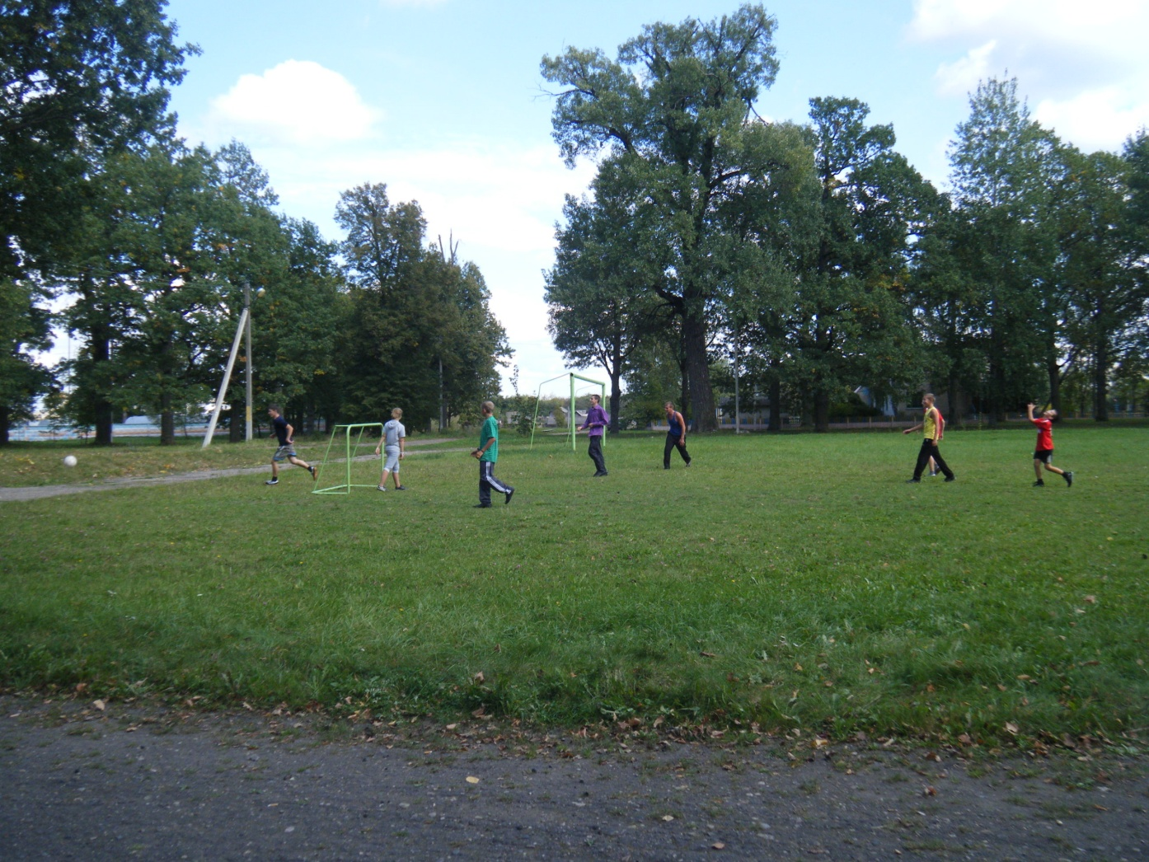

**Our future after the implementation of the project:**

