**США** (50 [штатов](https://ru.wikipedia.org/wiki/%D0%90%D0%B4%D0%BC%D0%B8%D0%BD%D0%B8%D1%81%D1%82%D1%80%D0%B0%D1%82%D0%B8%D0%B2%D0%BD%D0%BE%D0%B5_%D0%B4%D0%B5%D0%BB%D0%B5%D0%BD%D0%B8%D0%B5_%D0%A1%D0%A8%D0%90) и [федеральный округ](https://ru.wikipedia.org/wiki/%D0%A1%D1%82%D0%BE%D0%BB%D0%B8%D1%87%D0%BD%D0%B0%D1%8F_%D1%82%D0%B5%D1%80%D1%80%D0%B8%D1%82%D0%BE%D1%80%D0%B8%D1%8F) [Колумбия](https://ru.wikipedia.org/wiki/%D0%92%D0%B0%D1%88%D0%B8%D0%BD%D0%B3%D1%82%D0%BE%D0%BD_(%D0%BE%D0%BA%D1%80%D1%83%D0%B3_%D0%9A%D0%BE%D0%BB%D1%83%D0%BC%D0%B1%D0%B8%D1%8F)))

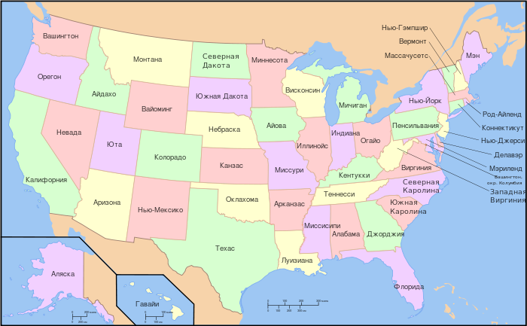

**США** (50 [штатов](https://ru.wikipedia.org/wiki/%D0%90%D0%B4%D0%BC%D0%B8%D0%BD%D0%B8%D1%81%D1%82%D1%80%D0%B0%D1%82%D0%B8%D0%B2%D0%BD%D0%BE%D0%B5_%D0%B4%D0%B5%D0%BB%D0%B5%D0%BD%D0%B8%D0%B5_%D0%A1%D0%A8%D0%90) и [федеральный округ](https://ru.wikipedia.org/wiki/%D0%A1%D1%82%D0%BE%D0%BB%D0%B8%D1%87%D0%BD%D0%B0%D1%8F_%D1%82%D0%B5%D1%80%D1%80%D0%B8%D1%82%D0%BE%D1%80%D0%B8%D1%8F) [Колумбия](https://ru.wikipedia.org/wiki/%D0%92%D0%B0%D1%88%D0%B8%D0%BD%D0%B3%D1%82%D0%BE%D0%BD_(%D0%BE%D0%BA%D1%80%D1%83%D0%B3_%D0%9A%D0%BE%D0%BB%D1%83%D0%BC%D0%B1%D0%B8%D1%8F)))

