# Supplement 1

The results of the survey of Belarusian pupils: “What are the floristic symbols of England, Scotland, Wales, Northern Ireland and Belarus? What are the motives of the choice of the national floral emblem?

We conducted a survey among 100 pupils of the 6-th – 11-th forms in Beniakoni school, which revealed their understanding on flower symbolism in the cultures of the Belarusians and the British. Pupils were asked the following questions.

1. What flower is the symbol of England? Why?

2. What flower is the symbol of Wales? Why?

3. What flower is the symbol of Scotland? Why

4. What flower is the symbol of Northern Ireland? Why?

5. What flower is the symbol of Belarus? Why?

6. Where are the national flowers of the UK and Belarus used?

After analyzing the results of the survey, we made the following diagrams

65 (65 percent) pupils know the symbol of England, but only 15 of them (15 percent) know the motives of the origin of this symbol.

42 (42 percent) pupils know the symbol of Scotland, but only 1 (1 percent) know the motives of the origin of this symbol.

39 (39 percent) pupils know the symbol of Wales, but nobody knows the motives of the origin of this symbol.

35 (35 percent) pupils know the symbol of Northern Ireland, but nobody knows the motives of the origin of this symbol.

82 (82 percent) pupils know the symbol of Belarus and 50 of them (50 percent) know the motives of the origin of this symbol.

Theresults of the survey of Belarusian pupils: Where are the national flowers of the UK and Belarus used?

84 (84 percent) pupils are sure that the national floral symbols are presented on the state emblems.

70 (70 percent) pupils suggested that national symbols are used in the official events, ceremonies, holidays as emblems or logos.

49 (49 percent) think that national floral symbols are used as clothing items.

12 (12 percent) pupils do not know where the floral symbols are used.

# Supplement 2

The results of the survey of British pupils: “What are the floristic symbols of England, Scotland, Wales, Northern Ireland and Belarus? What are the motives of the choice of the national floral emblem?

We asked more than 50 respondents aged 13 –17 from various parts of the UK. We’ve interviewed 50 teenagers (22 – from England, 5 - from Scotland, 7– from Wales, 16 – from Northern Ireland) in order to find out their level of awareness on their national floral symbols and Belarusians floral symbols, using the social network Instagram. Teenagers were asked the same questions.

1. What flower is the symbol of England? Why?

2. What flower is the symbol of Wales? Why?

3. What flower is the symbol of Scotland? Why

4. What flower is the symbol of Northern Ireland? Why?

5. What flower is the symbol of Belarus? Why?

6. Where are the national flowers of the UK and Belarus used?

After analysing the results of the survey, we made the following diagrams

41 (82 percent) pupils know the symbol of England, 36 of them (72 percent) know the motives of the origin of this symbol.

38 (76 percent) pupils know the symbol of Scotland, 40 (80 percent) knows the motives of the origin of this symbol.

46 (92 percent) pupils know the symbol of Wales, 41 (82 percent) knows the motives of the origin of this symbol.

44 (88 percent) pupils know the symbol of Northern Ireland, 38 (76 percent) knows the motives of the origin of this symbol.

14 (28 percent) pupils know the symbol of Belarus and only 2 (4 percent) knows the motives of the origin of this symbol.

The results of the survey of British pupils: Where are the national flowers of the UK and Belarus used?

35 (70 percent) pupils are sure that the national floral symbols are presented on the state emblems.

47 (94 percent) pupils think that national symbols are used in the official events, ceremonies, holidays as emblems or logos.

39 (78 percent) suggested that national floral symbols are used as clothing items.

4(8 percent) pupils do not know where the floral symbols are used.

# 

# Supplement 3

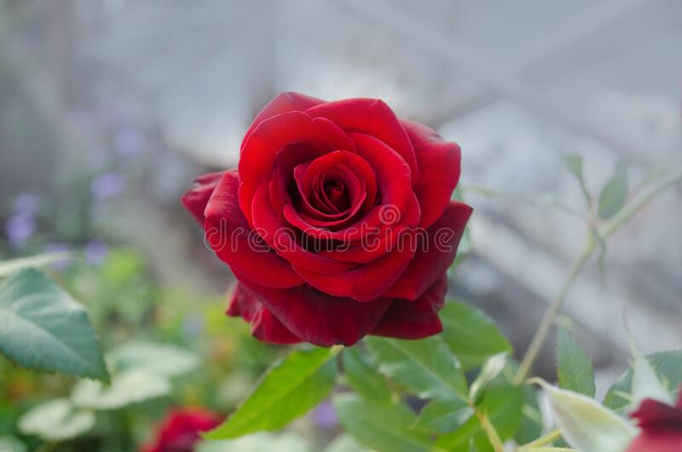

# Supplement 4

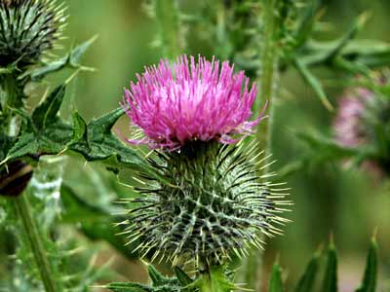

# Supplement 5

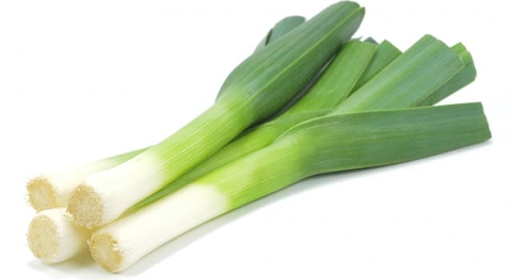

# Supplement 6

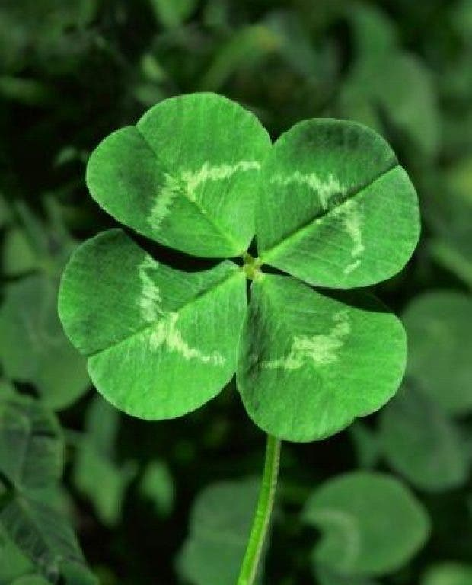

# Supplement 7

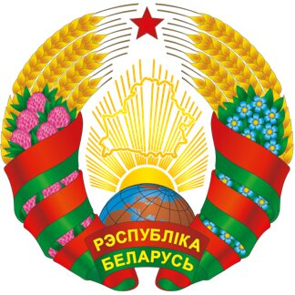

# Supplement 8

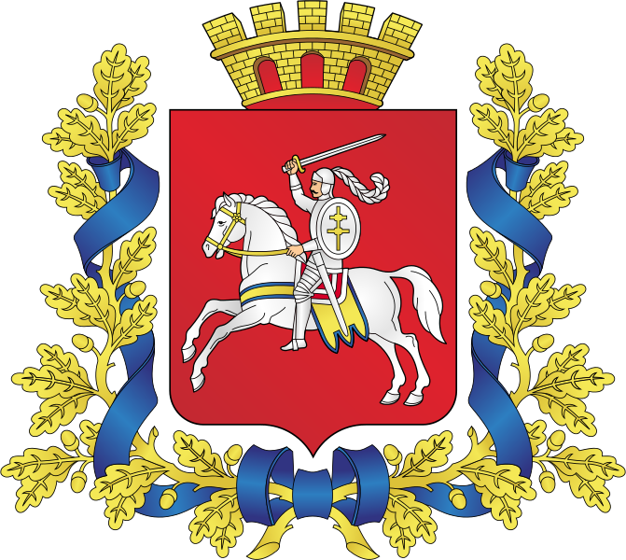

# Supplement 9

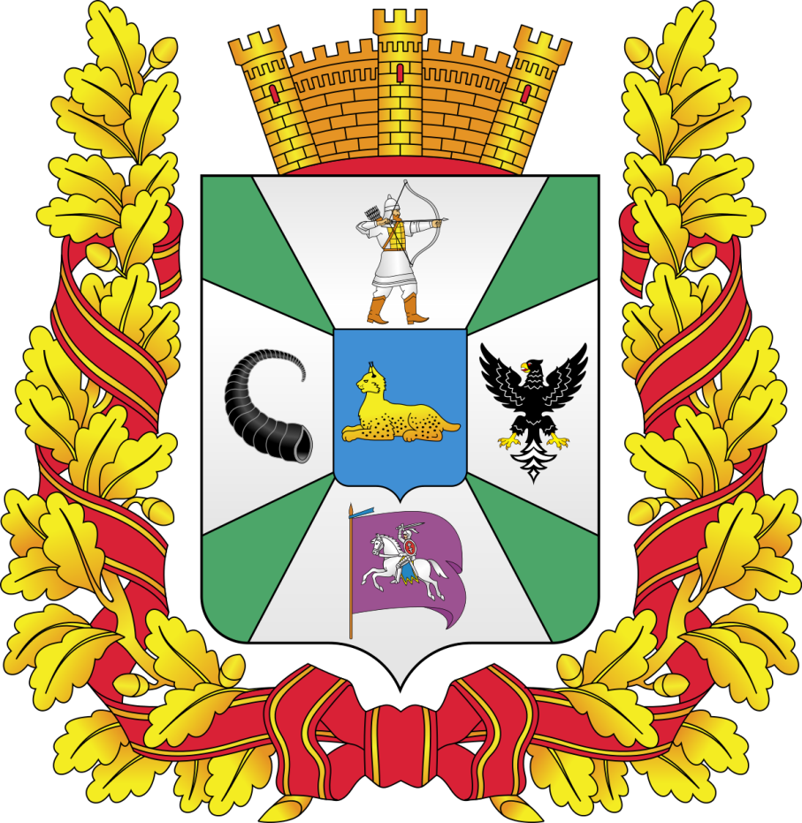

# Supplement 10

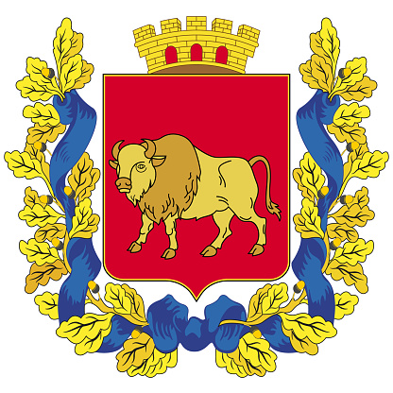

SUPPLEMENT 11

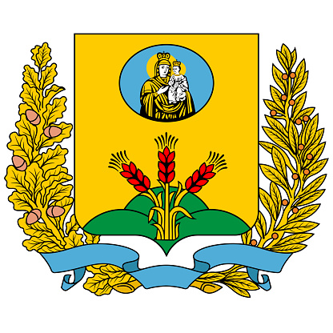

# Supplement 12

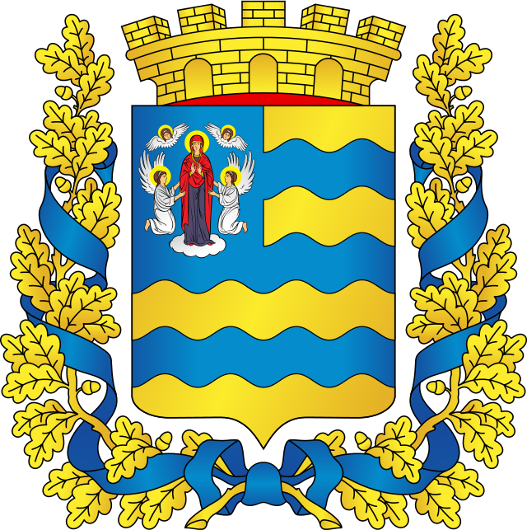

# Supplement 13

