**УРОК АНГЛИЙСКОГО ЯЗЫКА В I0 КЛАССЕ**

**ПО ТЕМЕ «МОЯ КОМНАТА»**

**С.Г. Таварницкая**,

учитель английского языка

высшей квалификационной категории

Ельской районной гимназии

**Тема урока:** Моя комната. Говорение.

**Тип урока:** урок развития речевых умений учащихся.

**Цель (прогнозируемый результат):** предполагается, что к окончанию урока учащиеся смогут составить скрипт для видео-рассказа о своей комнате, опираясь на информацию, полученную в течение урока.

**Коммуникативные задачи:**

* активизировать языковой материал в устной речи;
* способствовать развитию умений использовать в устной речи информацию, полученную при восприятии речи на слух;
* создать условия для развития умения аргументированно выражать свою точку зрения;
* способствовать развитию критического мышления;

**Методы:** коммуникативный, интерактивный.

**Оборудование:** доска, раздаточный материал, магниты, видеозаписи, мультимедийная презентация, компьютер, мультимедийный проектор.

|  |  |  |  |  |
| --- | --- | --- | --- | --- |
| № | Этап урока | Деятельность учителя | Учебный режим | Время |
| 1 | 2 | 3 | 4 | 5 |
| 1 | **Организационно-мотивационный этап**  Введение в атмосферу иноязычного общения | Hello, my dears! Ihave started our lesson with this old song because of its title. What is it?  (“In my room” by The Beach Boys)  Do you own a room or share it with your siblings?  I guess you hardly know about the rooms your groupmates have. Let’s ask one another this question and see the real picture. | T – Cl  P1-P2… | 3 |
| 2 | **Этап актуализации знаний и целеполагания**  Определение личностного отношения учащихся к проблеме. | Is it nice to have a room of your own?  Of course it is.  And for teens it’s really very important. Their room is a special place for them.  So today we are going to speak about teens and their rooms.What do their rooms look like? What is special about them? Do teens really need a private zone in the house/flat? | T – Cl | 2 |
| 3 | **Операционно -познавательный этап.**  1. Формирование коммуникативных навыков с использованием текста и раздаточного материала. | Look through the lyrics of the song you have heard and find the key words to answer the question:“What is the role of a room in our life?”*(Прил. 1.)*  Let’s make a summary. Match the suitable nouns to describe the role of the room with the sentences from the list. *(Прил. 2.)*  Stick the nouns on the board and make your comments on the point. Use the key words from the song as well. | P1-P2… | 7 |
|  | 2. Формирование коммуникативных навыковна основе изображений с опорой на лексические единицы урока.  Подготовительный этап. | We are very different, so our rooms are different as well.  Is there any difference between boy’s and girl’s rooms?  What are your associations with boy’s/girl’s room?  Let’s divide into 2 groups: boys and girls.  I’ll give you a set of very typical things that can be often found in the rooms. You are to divide them into 2 groups: boyish things and girlish ones.  Put them in the right column!*(Прил. 3.)* | T – Cl  Gr1 – Gr2 | 5 |
|  | Говорение. | Let’s have a look at some very boy’s rooms and girly ones.  You are to guess who the rooms belong to and prove your ideas.  What other information can we get from the rooms: character, interests, hobbies…?  In what style are the rooms decorated? – traditional, sport, music, geographical, sea…  And 3 more pictures just for fun. Whose room can these statements be about and what do they mean?   1. Nothing to wear… 2. My room is like the Bermuda triangle, stuff goes in and is never seen again. 3. If my room is clean, it means that the Internet is not working. | P1-P2… | 10 |
|  | 3. Формирование коммуникативных навыковна основе просмотренного видео. | Now are you good experts in rooms.  In a few minutes you are to watch the video “My room tour” made by a teenager. He is a blogger. Can you predict what we can see in his room? You are welcome with your ideas.  Well and one more thing before watching. Look through the list of the questions you are to answer after watching.  *(Прил. 4.)*  So be attentive and enjoy the room tour.  Now read the question in turn and answer them, please.  Who can tell a short story about Jake’s room? | T – Cl  P1-P2… | 12 |
| 4 | **Контрольно-оценочный этап**  1. Рефлексия . | Great! That’s enough for today.  I enjoyed working with you today and hope you too.   * Did you enjoy our lesson? * What part was the most interesting for you? * … the most difficult? * … the easiest? * … the funniest? * Was there anything you didn’t like doing? * Can you follow Jake’s example and make your room tour? | T – Cl | 3 |
|  | 2. Предъявление домашнего задания.  Подведение итогов урока. | Ok, we have seen and described a lot of rooms, have watched the videо room tour and now it’s your turn to present your rooms.  Your home task is to write a script for your room video tour. My tips “Planning your video “My room tour” will be a helpful hand.  *(Прил. 5.)*  Tomorrow I’ll check them and at the weekend you’ll bе busy making a video. You have up to date phones with good cameras and I hope you’ll enjoy being video-makers. May be you’ll even want to download it in You Tube. Why not?  And the last point for today – your marks ….  Thanks. See you tomorrow. And I’m looking forward to seeing your videos. |  | 3 |

Ссылка на видеоматериал к уроку:

https://www.youtube.com/watch?time_continue=65&v=-b5WsEDZvsE

https://www.youtube.com/watch?time_continue=10&v=ZtadNUx-_ng

[Ссылка на Презентация](https://cloud.mail.ru/public/JLZB/5A25yWTvL)

*Приложение 1*

"In My Room"

There's a world where I can go and tell my secrets to  
In my room, in my room  
In this world I lock out(скрыть) all my worries(беспокойства) and my fears(страхи)  
In my room, in my room  
  
Do my dreaming and my scheming(замыслы)  
Lie awake(лежать) and pray(молиться)  
Do my crying and my sighing(вздыхать)  
Laugh(смеяться) at yesterday  
  
Now it's dark and I'm alone(один)  
But I won't be afraid(бояться)  
In my room, in my room  
In my room, in my room  
In my room, in my room

*Приложение 2*

Castle, fortress , church(a cell), heaven, safe, snack bar, sport club, party club, music club, entertainment place, gallery, mirror

We can hide here from everything and everyone.

It protects us from troubles, worries, danger.

We pray, we talk to the god, ask for advice or help.

We feel calm and happy there.

We have snacks and drinks there.

We do sports there.

We invite our friends and have fun.

We listen to our favourite songs, sing and play musical instruments.

We keep our treasures and secrets there.

We watch films, play games and just relax there.

We keep our favourite and valuable things there.

It reflects our personality, shows our interests and hobbies.

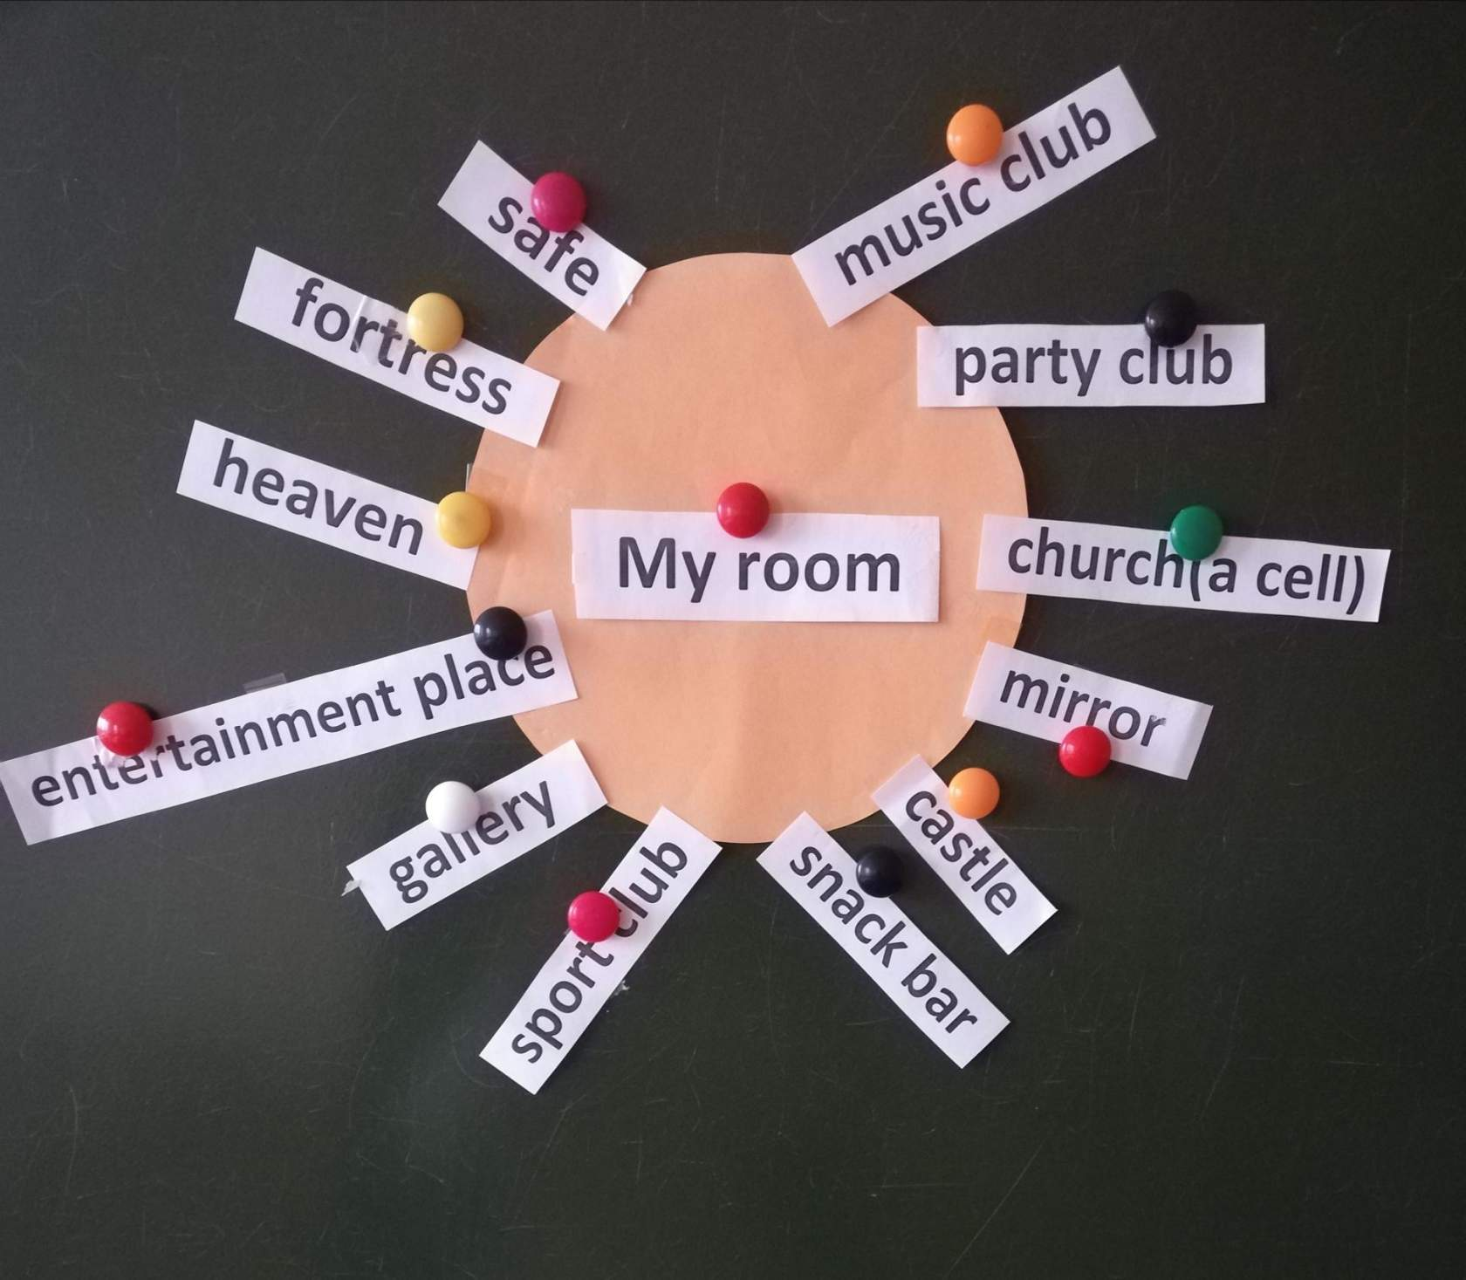

*Приложение 3*

Plain/dark colours, bright colours, a lot of pink colour, sport staff, dolls, soft toys, parfums, a lot of pillows, jewelry, sport posters, celebrities’ posters, simple furniture, stylish furniture, messy room, tidy room, flower patterns, make up staff, hair staff, dresser, hearts everywhere, butterflies, black sunglasses, maps, vases, candles, balls, mirrors, guitars, car-models /car-prints, dinosaurs/ monsters, boxing gloves, punching bag

*Приложение 4*

My Room Tour

plaque - значок

junk - барахло

built-in - встроенный

headboard – изголовьекровати

storagedevice – приспособление для хранения

remote - пульт

Xboxcontrol – игровая приставка

hanger – вешалка-плечики

handle – ручка двери

bin – мусорное ведро

hinge – двернаяпетля

- What is the boy’s name?

- Why did he decide to make this video “My room tour”?

- What did he start his tour with?

- How does he call his notebook?

- What did he get his You Tube prize (plaque) for?

- What staff does he keep in his chest of drawers?

- What kind of wardrobe does he have?

- What is the main part of his bedroom?

- What does he have along his headboard?

- What secret does his bed have?

- What other items did he mention in his video? Cross 2 odd ones out: a plant(mini bonzai), a door hinge, a mirror, a bookcase, a hanger, a door handle, a lamp, a TV remote, a pair of earphones, a microphone, Xbox control, a carpet, a window, a floor, a bin, a door.

*Приложение 4*

Planning your video “My room tour”

1. Greeting
2. Motto
3. Role
4. Style
5. Size
6. Main colours
7. Furniture
8. Decorations
9. Dearest things
10. Main thing
11. Advantages/disadvantages
12. Saying good bye

Helpful phrases

1. I live by the motto “My room is my ___________________”
2. There I _________________________________________________________
3. It’s rather small/ neither large nor small/ specious.
4. But it easily holds all the staff I need to relax and feel right at home:

a ___________, a __________...

1. It has ________ wallpapers. / The walls are painted with _______ colour.
2. On the windows you can see ___________ curtains.
3. On the floor I’ve got a ___________________.
4. The main part of my room is my _________ because _____________________
5. The things that give my room its unique style are a __________, …

The things that give the room a nice touch of style are a __________, …

The things that mean a lot to me are ________________

Many have complimented me on my ­­­­­­­­­­­­­­­­­­­­­­­­­­­­___________________________________

1. The great advantage of my room is that _________________________________
2. I try to keep my room tidy/ It’s a pity my room is often messy.
3. I love my room and enjoy spending time there.

